SMART LIGHTNING MANAGEMENT SYSTEM
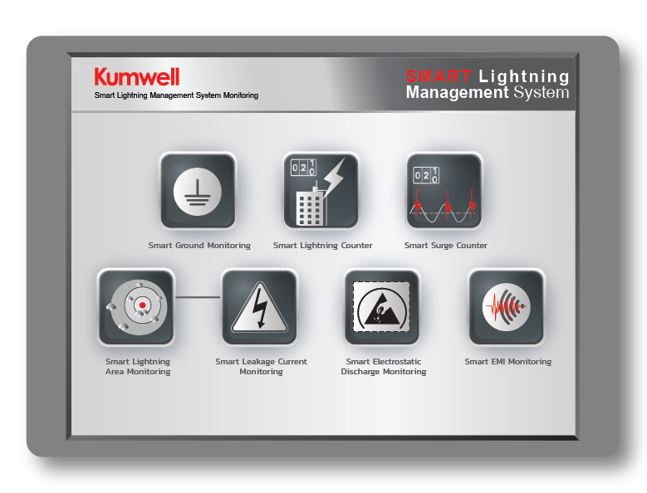
The KUMWELL Smart Lightning Management System (SLMS) is an advanced digital monitoring solution that provides continuous supervision of lightning protection, grounding, and surge protection systems. By delivering real-time status updates, lightning event monitoring, and instant alarm notifications, the system enhances personnel safety while protecting critical infrastructure, buildings, communication networks, and operational assets from lightning-related threats.

Through an intuitive web-based platform, SLMS transforms conventional lightning protection systems into intelligent, data-driven assets. Comprehensive system diagnostics, event logs, performance analytics, and maintenance reports are accessible anytime, enabling maintenance teams and control room operators to quickly identify faults, assess system health, and respond proactively.

By supporting predictive maintenance and condition-based asset management, SLMS helps reduce downtime, improve system reliability, optimize maintenance costs, and ensure that lightning protection systems remain fully operational and compliant throughout their service life.

